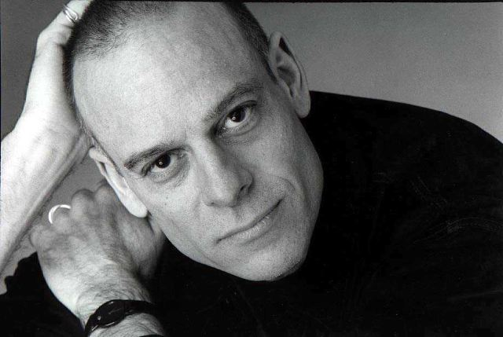
MICHAEL BIAGI (Music Director) Is thrilled to be united once again with long-time collaborator, Tommy Tune. Taps, Tunes and Tall Tales, marks the latest project in their 38-year collaboration. Michael was Music Director for the world premiere of Turn Of The Century, starring Jeff Daniels and Rachel York at Chicago's Goodman Theater. During the past three decades, Michael has served as music director for many of Tune's projects, including: Dr. Dolittle, White Tie and Tails, Bye Bye Birdie, and Tommy Tune Tonight!. In addition to two appearances on The Tonight Show with Jay Leno and numerous symphonic concerts with Tommy and the Manhattan Rhythm Kings, Michael provided music direction for the U.S. Premiere of What Ever Happened to Baby Jane? at Houston’s Theater Under The Stars. Other national/international credits include: Will Rogers Follies, Damn Yankees, Grease!, Grand Hotel, The King and I, and West Side Story.Michael has been privileged to “keep time” for such luminaries as George Burns, Carol Channing, Rudolf Nureyev, and the ‘inimitable’ Charles Pierce.

PATRICK RINN (Production Supervisor/Lighting Design)
Patrick celebrates his 25th year working with Mr. Tune in some capacity or another. Productions include Steps In Time, Doctor Dolittle, White Tie & Tails, Tommy Tune Tonite, The Will Rogers Follies, Best Little Whorehouse Goes Public, Bye Bye Birdie, and Grand Hotel. In addition to his work with Mr. Tune, he has worked as a Production Supervisor for many concerts: Prince, Diana Ross, Dave Mathews, Patti LaBelle, Dionne Warwick, Chic, Paul Simon, Billy Joel, Tom Petty, B52’s, & Adam Lambert. He has also worked as lighting designer for Steps In Time, Taps, Tunes & Tall Tail’s, Night of 1000 Gowns, and several Off-Broadway productions.

